National University of Computer and Emerging Sciences



Laboratory Manuals
for
Computer Networks - Lab

(CL -3001)

Course Instructor
Lab Instructor(s)
Section
Semester

Department of Computer Science
FAST-NU, Lahore, Pakistan

Lab Manual 07

Objective:
- Analyzing the FTP packets using Wireshark
- TCP Socket Programming using Multithreaded Server to handle multiple clients at the same time

Lab Statement 1: Capturing FTP packets using Wireshark (10)

Step 1: Start a Wireshark capture.
a. Close all unnecessary network traffic, such as the web browser, to limit the amount traffic during the Wireshark capture.
b. Start the Wireshark capture.
Step 2: Download the .txt file.
a. From the command prompt, enter ftp ftp.mcafee.com
b. Log into the FTP site for mcafee.com with user anonymous and no password.
c. Locate and download any .txt file.

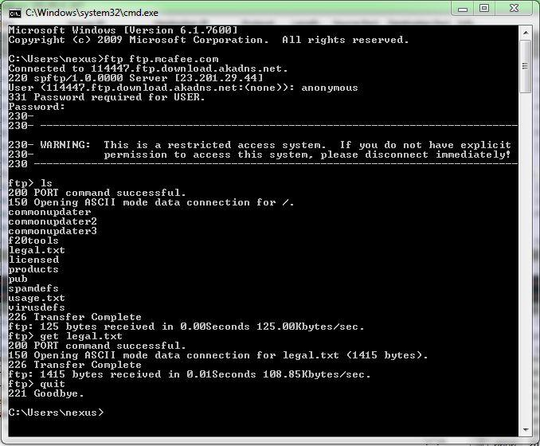

Step 3: Stop the Wireshark capture.

Step 4: View the Wireshark Main Window
Wireshark captured many packets during the FTP session to ftp.mcafee.com. To limit the amount of data for analysis, type tcp and ip.addr == 195.89.6.167 in the Filter. The IP address, 195.89.6.167, is the address for ftp.mcafee.com.

Step 5: Analyze the packets
Carefully analyze the packets in Wireshark windows and answer the following question:
Use the FTP_Session.pcapng (Wireshark Capture File) to answer the questions below

- FTP uses two port numbers: 20 and 21. Apply tcp.port==20 and tcp.port==21. Analyze the result and write down the purposes of these two ports for FTP.

- Filter out each packet using either FTP or FTP-DATA Protocol (using ftp || ftp-data filter). Mention each packet number and its purpose with reference to request made and response received in the above mentioned FTP Session in command line to get file legal.txt (screenshot show above). Also look for Response Code and Response Arg in the FTP Header for each packet
(There are 19 such packets and you have to write one/two lines explanation for each packet, what the packet is doing w.r.t FTP Session (Screenshot shown above) e.g., Packet 104: Client asks server to send the data on IP:192.168.1.2 and Port:16341 [63(0x3F),213(0xD5) and (0x3FD5=16341)] )

Lab Statement 2: Analyzing ICMP Packets using Wireshark (10)

- Step 1: Run Wireshark
- Step 2: Load the Session file ICMP_Session
- Step 3: Now filter out all non-ICMP packets by typing “icmp” (without quotes) in the filter field towards the top of the Wireshark window
- Step 4: Analyze the ICMP Packets and answer the following questions

- Are ICMP messages sent over UDP or TCP?
- What is the link-layer (e.g., Ethernet) address of the host?
- Which kind of request is sent through these ICMP packets?
- How many requests are sent through the host?
- What is the IP address of your host? What is the IP address of the destination host?
- Why is it that an ICMP packet does not have source and destination port numbers?
- What values in the ICMP request message differentiate this message from the ICMP reply message?
- Examine one of the ping request packets sent by your host. What are the ICMP type and code numbers? What other fields does this ICMP packet have? How many bytes are the checksum, sequence number and identifier fields?

- Examine the corresponding ping reply packet. What are the ICMP type and code numbers? What other fields does this ICMP packet have? How many bytes are the checksum, sequence number and identifier fields?

- Examine the packet no 56. What are the ICMP type and code numbers? Why is the IP and TCP Header included in the ICMP Header? What does these headers depict?

